QUIZ 1

AND Gate
From our knowledge of logic gates, we know that an AND logic table is given by the diagram below

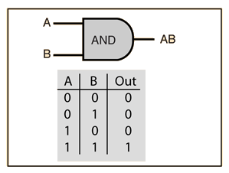
AND Gate
The question is, what are the weights and bias for the AND perceptron?
First, we need to understand that the output of an AND gate is 1 only if both inputs (in this case, x1 and x2) are 1. So, following the steps listed above;
Row 1
- From w1*x1+w2*x2+b, initializing w1, w2, as 1 and b as –1, we get;
x1(1)+x2(1)–1
- Passing the first row of the AND logic table (x1=0, x2=0), we get;
0+0–1 = –1
- From the Perceptron rule, if Wx+b≤0, then y`=0. Therefore, this row is correct, and no need for Backpropagation.
Row 2
- Passing (x1=0 and x2=1), we get;
0+1–1 = 0
- From the Perceptron rule, if Wx+b≤0, then y`=0. This row is correct, as the output is 0 for the AND gate.
- From the Perceptron rule, this works (for both row 1, row 2 and 3).
Row 4
- Passing (x1=1 and x2=1), we get;
1+1–1 = 1
- Again, from the perceptron rule, this is still valid.
Therefore, we can conclude that the model to achieve an AND gate, using the Perceptron algorithm is;
x1+x2–1

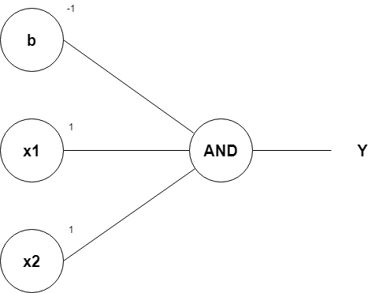

OR Gate

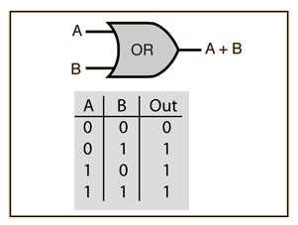
OR Gate
From the diagram, the OR gate is 0 only if both inputs are 0.
Row 1
- From w1x1+w2x2+b, initializing w1, w2, as 1 and b as –1, we get;
x1(1)+x2(1)–1
- Passing the first row of the OR logic table (x1=0, x2=0), we get;
0+0–1 = –1
- From the Perceptron rule, if Wx+b≤0, then y`=0. Therefore, this row is correct.
Row 2
- Passing (x1=0 and x2=1), we get;
0+1–1 = 0
- From the Perceptron rule, if Wx+b <= 0, then y`=0. Therefore, this row is incorrect.
- So we want values that will make inputs x1=0 and x2=1 give y` a value of 1. If we change w2 to 2, we have;
0+2–1 = 1
- From the Perceptron rule, this is correct for both the row 1 and 2.
Row 3
- Passing (x1=1 and x2=0), we get;
1+0–1 = 0
- From the Perceptron rule, if Wx+b <= 0, then y`=0. Therefore, this row is incorrect.
- Since it is similar to that of row 2, we can just change w1 to 2, we have;
2+0–1 = 1
- From the Perceptron rule, this is correct for both the row 1, 2 and 3.
Row 4
- Passing (x1=1 and x2=1), we get;
2+2–1 = 3
- Again, from the perceptron rule, this is still valid. Quite Easy!
Therefore, we can conclude that the model to achieve an OR gate, using the Perceptron algorithm is;
2x1+2x2–1
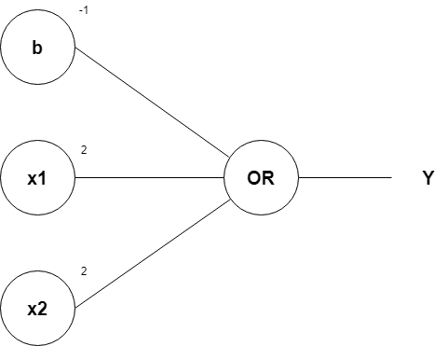

NOT Gate

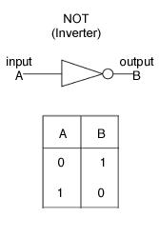
NOT Gate

From the diagram, the output of a NOT gate is the inverse of a single input. So, following the steps listed above;
Row 1
- From w1x1+b, initializing w1 as 1 (since single input), and b as –1, we get;
x1(1)–1
- Passing the first row of the NOT logic table (x1=0), we get;
0–1 = –1
- From the Perceptron rule, if Wx+b≤0, then y`=0. This row is incorrect, as the output is 1 for the NOT gate.
- So we want values that will make input x1=0 to give y` a value of 1. If we change b to 1, we have;
0+1 = 1
- From the Perceptron rule, this works.

NOR Gate

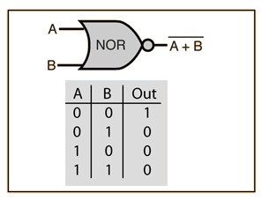
NOR Gate
From the diagram, the NOR gate is 1 only if both inputs are 0.
Row 1
- From w1x1+w2x2+b, initializing w1 and w2 as 1, and b as –1, we get;
x1(1)+x2(1)–1
- Passing the first row of the NOR logic table (x1=0, x2=0), we get;
0+0–1 = –1
- From the Perceptron rule, if Wx+b≤0, then y`=0. This row is incorrect, as the output is 1 for the NOR gate.
- So we want values that will make input x1=0 and x2 = 0 to give y` a value of 1. If we change b to 1, we have;
0+0+1 = 1
- From the Perceptron rule, this works.
Row 2
- Passing (x1=0, x2=1), we get;
0+1+1 = 2
- From the Perceptron rule, if Wx+b > 0, then y`=1. This row is incorrect, as the output is 0 for the NOR gate.
- So we want values that will make input x1=0 and x2 = 1 to give y` a value of 0. If we change w2 to –1, we have;
0–1+1 = 0
- From the Perceptron rule, this is valid for both row 1 and row 2.
Row 3
- Passing (x1=1, x2=0), we get;
1+0+1 = 2
- From the Perceptron rule, if Wx+b > 0, then y`=1. This row is incorrect, as the output is 0 for the NOR gate.
- So we want values that will make input x1=0 and x2 = 1 to give y` a value of 0. If we change w1 to –1, we have;
–1+0+1 = 0
- From the Perceptron rule, this is valid for both row 1, 2 and 3.
Row 4
- Passing (x1=1, x2=1), we get;
-1-1+1 = -1
- From the Perceptron rule, this still works.
Therefore, we can conclude that the model to achieve a NOR gate, using the Perceptron algorithm is;
-x1-x2+1

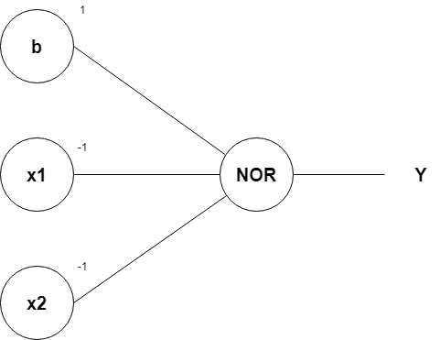

NAND Gate

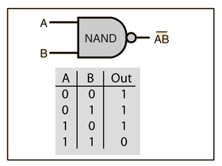
From the diagram, the NAND gate is 0 only if both inputs are 1.
Row 1
- From w1x1+w2x2+b, initializing w1 and w2 as 1, and b as -1, we get;
x1(1)+x2(1)-1
- Passing the first row of the NAND logic table (x1=0, x2=0), we get;
0+0-1 = -1
- From the Perceptron rule, if Wx+b≤0, then y`=0. This row is incorrect, as the output is 1 for the NAND gate.
- So we want values that will make input x1=0 and x2 = 0 to give y` a value of 1. If we change b to 1, we have;
0+0+1 = 1
- From the Perceptron rule, this works.
Row 2
- Passing (x1=0, x2=1), we get;
0+1+1 = 2
- From the Perceptron rule, if Wx+b > 0, then y`=1. This row is also correct (for both row 2 and row 3).
Therefore, we can conclude that the model to achieve a NAND gate, using the Perceptron algorithm is;
-x1-x2+2

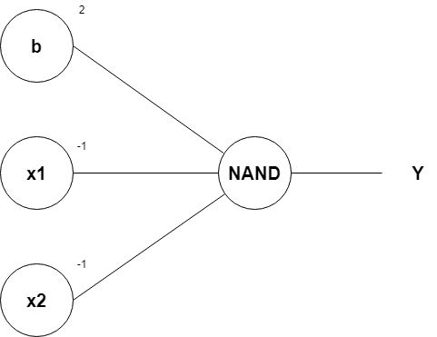

XNOR Gate

Now that we are done with the necessary basic logic gates, we can combine them to give an XNOR gate.
The boolean representation of an XNOR gate is;
x1x2 + x1`x2`
Where ‘`' means inverse.
From the expression, we can say that the XNOR gate consists of an AND gate (x1x2), a NOR gate (x1`x2`), and an OR gate.
This means we will have to combine 3 perceptrons:
- AND (x1+x2–1)
- NOR (-x1-x2+1)
- OR (2x1+2x2–1)

XOR Gate

XOR Gate
The boolean representation of an XOR gate is;
x1x`2 + x`1x2
We first simplify the boolean expression
x`1x2 + x1x`2 + x`1x1 + x`2x2
x1(x`1 + x`2) + x2(x`1 + x`2)
(x1 + x2)(x`1 + x`2)
(x1 + x2)(x1x2)`
From the simplified expression, we can say that the XOR gate consists of an OR gate (x1 + x2), a NAND gate (-x1-x2+1) and an AND gate (x1+x2–1.5).
This means we will have to combine 2 perceptrons:
- OR (2x1+2x2–1)
- NAND (-x1-x2+2)
- AND (x1+x2–1)

QUIZ 2

The score for one alignment (or path, as it is often called in the literature) is calculated by multiplying the corresponding character scores together. In the example shown above, the score for the path “aa” is 0.4·0.4=0.16 while it is 0.4·0.6=0.24 for “a-” and 0.6·0.4=0.24 for “-a”. To get the score for a given GT text, we sum over the scores of all paths corresponding to this text. Let’s assume the GT text is “a” in the example: we have to calculate all possible paths of length 2 (because the matrix has 2 time-steps), which are: “aa”, “a-” and “-a”. We already calculated the scores for these paths, so we just have to sum over them and get 0.4·0.4+0.4·0.6+0.6·0.4=0.64. If the GT text is assumed to be “”, we see that there is only one corresponding path, namely “--”, which yields the overall score of 0.6·0.6=0.36

Best path decoding is, of course, only an approximation. It is easy to construct examples for which it gives the wrong result: if you decode the matrix from Fig. 3, you get “” as the recognized text. But we already know that the probability of “” is only 0.36 while it is 0.64 for “a”. However, the approximation algorithm often gives good results in practical situations. There are more advanced decoders such as beam-search decoding, prefix-search decoding or token passing, which also use information about language structure to improve the results.

QUIZ 3

For each CNN layer, create a kernel of size k×k to be used in the convolution operation

Codes
kernel = tf.Variable(tf.truncated_normal([k, k, chIn, chOut], stddev=0.1))
conv = tf.nn.conv2d(inputTensor, kernel, padding='SAME', strides=(1, 1, 1, 1))

Then, feed the result of the convolution into the RELU operation and then again to the pooling layer with size px×py and step-size sx×sy.

Codes
relu = tf.nn.relu(conv)
pool = tf.nn.max_pool(relu, (1, px, py, 1), (1, sx, sy, 1), 'VALID')
These steps are repeated for all layers in a for-loop.

RNN
Create and stack two RNN layers with 256 units each.

Codes
cells = [tf.contrib.rnn.LSTMCell(num_units=256, state_is_tuple=True) for _ in range(2)]
stacked = tf.contrib.rnn.MultiRNNCell(cells, state_is_tuple=True)

Then, create a bidirectional RNN from it, such that the input sequence is traversed from front to back and the other way round. As a result, we get two output sequences fw and bw of size 32×256, which we later concatenate along the feature-axis to form a sequence of size 32×512. Finally, it is mapped to the output sequence (or matrix) of size 32×80 which is fed into the CTC layer.

If you want to improve the recognition accuracy, you can follow one of these hints:
- Data augmentation: increase dataset-size by applying further (random) transformations to the input images
- Increase input size (if input of NN is large enough, complete text-lines can be used)
- Add more CNN layers
- Replace LSTM by 2D-LSTM
- Text correction: if the recognized word is not contained in a dictionary, search for the most similar one

Conclusion

We discussed a NN which is able to recognize text in images. The NN consists of 5 CNN and 2 RNN layers and outputs a character-probability matrix. This matrix is either used for CTC loss calculation or for CTC decoding. An implementation using TF is provided and some important parts of the code were presented. Finally, hints to improve the recognition accuracy were given

